Now we are going to talk about Button and onPress event
teacher was thinking to teach us about state but if you want to understand the state in depth then you should have an event then you can understand state and how you can update it then what is the reason behind the logic and how does it work you can easily underastand it

So first of all we need to create a button
And then we see how to change the color of button
How to call a function on button press event

Button don't have click event in our React native Click event is inside our Web , windows but if we talk about Mobile then we tap there
Click is associated with mouse pointer it is not associated with touch on the screen

Then we will see how to pass data maybe to funvtion of event(who knows)

adn then we will discuss some interview question

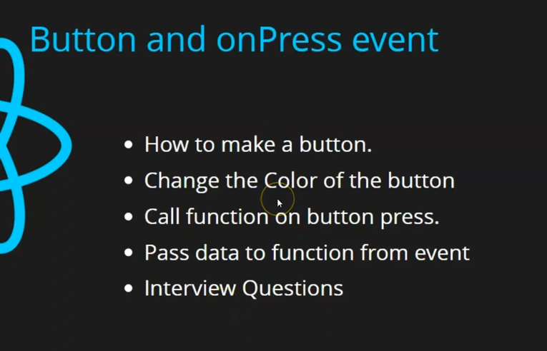
and then in next part we will discuss state so that you can understand state or update state
So we import button in react native
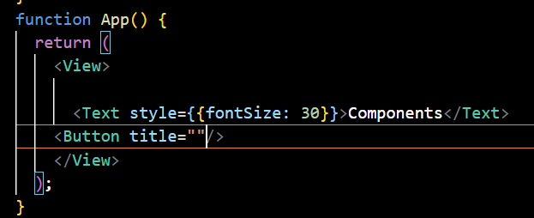
Button should have a title attribute or prop(later) so that you can tell the label fore button

Note:-
If you want to understadn a language then staret reading its error

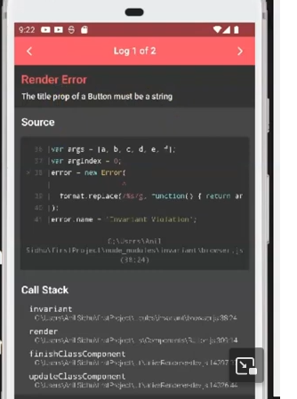
The above error means we have not given string value to title as no value is given to it
When we preess on OnPress button then nothiong happens beacuse we have one nothing on it
We can change the color of the button by color attribut but when you give it value then give it in {} and in between color in strings

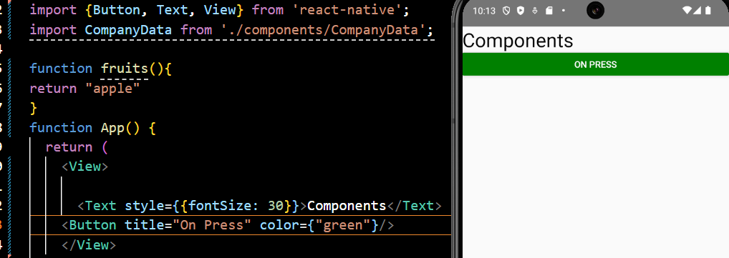
the curly bracket make things dynamic and sinple string will make us dynamic

3:27

Now the question how can i call the function on the click of the button
So suppose we make a function named as fruit and then inside it we call console.warn()
It works here and used by teh beginners to debug
now we use the attribute onPress and the assign it function name

function App() {
const fruits=()=>{
console.warn("Function called")
}
return (
<View>
<Text style={{fontSize: 30}}>Components</Text>
<Button title="On Press" onPress={fruits} color={"green"}/>
</View>
);
}

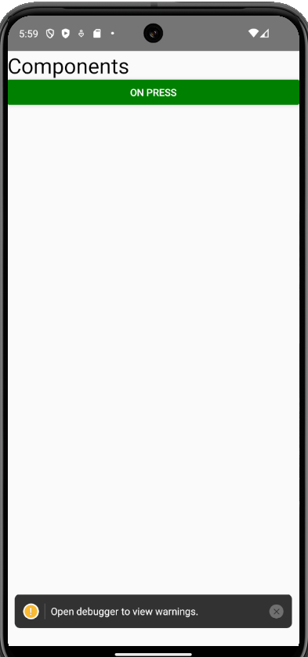
Now you can see the bottom message on the click of the button now when you click on it then
a new window will be shown to show the console as shown below

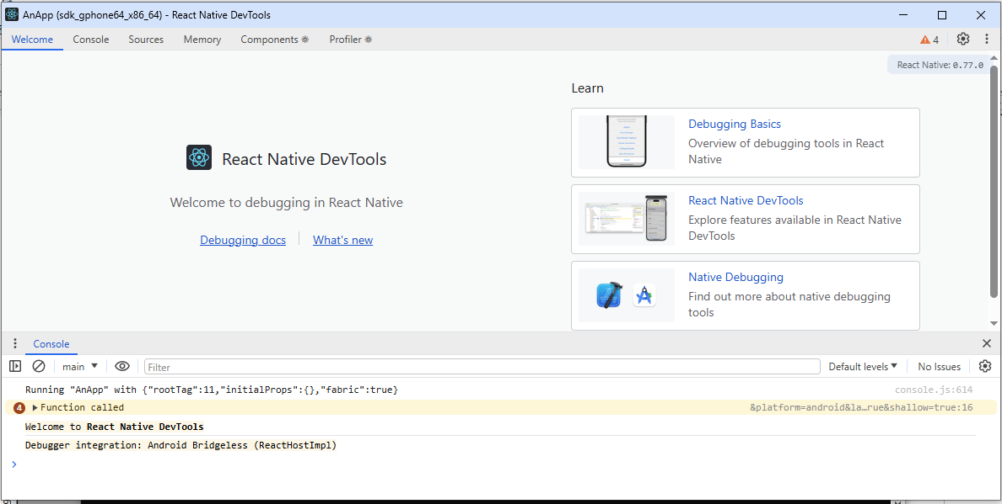
console.log result is shown in the debugger so it is better to use console.warn

Now if we have simply called the function by using () after its name in onPress attribute then the function will be called once but ont be used as an event handler because it neds its address i think so that's why function name was used in onPress attribute in Button

But if you want to call the event handler with parameters

then enclose it inside an arrow function and then call it as shown below

function App() {
const fruits=(val="Ramu")=>{
console.log(val)
}
return (
<View>
<Text style={{fontSize: 30}}>Components</Text>
<Button title="On Press" onPress={()=>fruits()} color={"green"}/>
<Button title="On Press2" onPress={()=>fruits("Hello Jatin")} color={"green"}/>
</View>
);
}

The first button uses even handler without parameters and second with parameters

Now we click on second nbutton then Hello Jatin is called and click on fisrt button is clicked
then Ramu is written as it s the default value of val

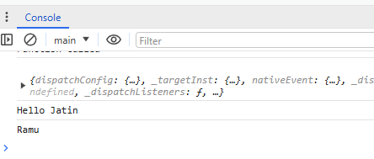
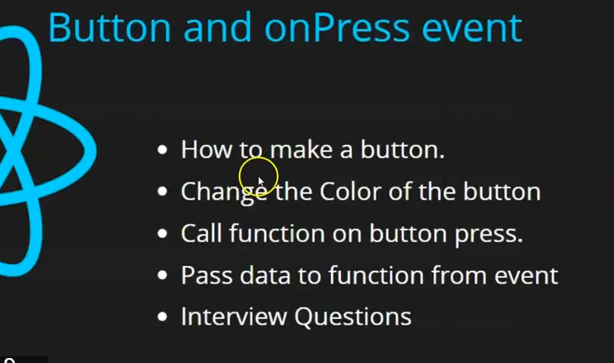
Now we have seen all tht top 4 but now the teacher will show us something interesting that shows us why state is required
You may get confused (not confused just it will be like a cliffhanger)

So now suppose we declare a variable called data inide compoent and then ue it in between teh trext as shown below

function App() {
let data = 10
const fruits=(val="Ramu")=>{
data=100
console.log(data)
}
return (
<View>
<Text style={{fontSize: 30}}>{data}</Text>
<Button title="On Press" onPress={()=>fruits()} color={"green"}/>
<Button title="On Press2" onPress={()=>fruits("Hello Jatin")} color={"green"}/>
</View>
);
}

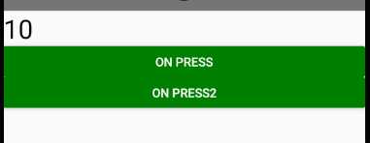
if we make it 100 then 100 will shown
but suppose we print the value of data before reinitallising it with 20 before the console.warn in fruits function
Now if you click on thr button then 100 value will be shown but no change in text is detected
even if you referesh then it still willshow 10 because till that timw no fruit function is called

It is an interview questiion

If you want to understand state then it is a good example whihc we will discuss in next lesson

9:00

